**1.** The frequency distribution of brokerage commission earned in a month from a survey of 300 stock brokers is as follows:

**Rs. Frequency**

0-5000 15

5000-10000 25

10000-15000 35

15000-20000 125

20000-25000 70

25000+ 30

What is the probability that a randomly selected stock broker earns:

1. Rs.5000-Rs.10000;
2. more than Rs.15000

**Solution:**

1. Probability that selected broker earns Rs.5000-10000

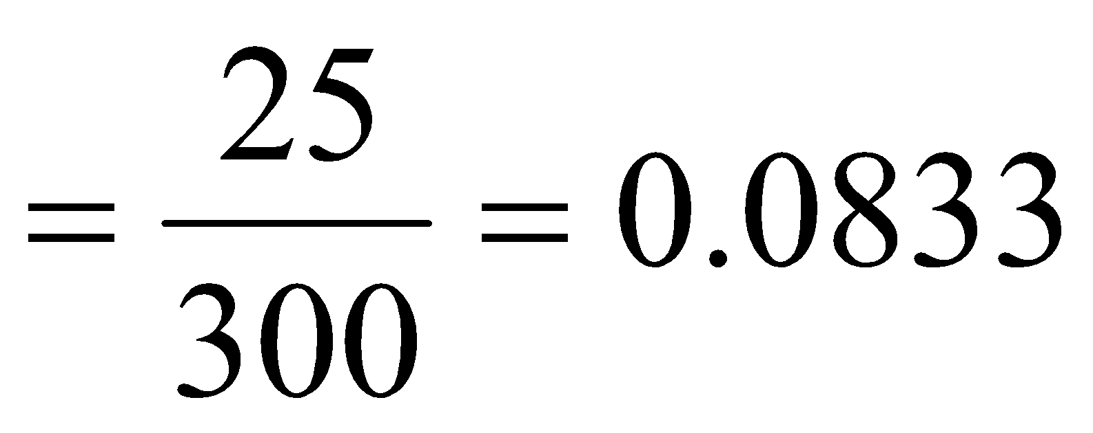

1. Probability that selected broker earns more than Rs. 15000

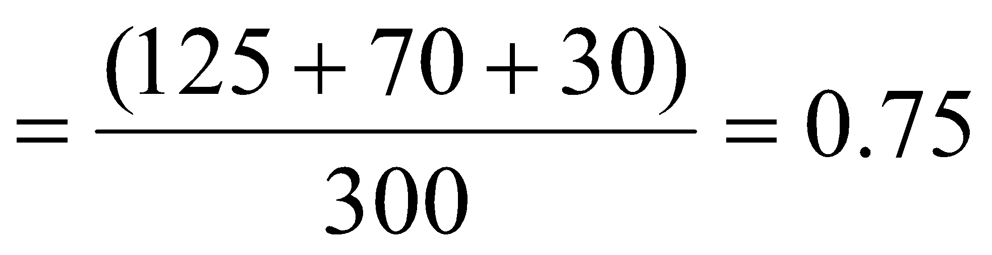

2. Consider an experiment of rolling a fair dice. Let the event A is an even number appears on the upper face. The event B is the number on the upper face is greater than 3. Find the probability of the number appearing on the upper face is either event A or B.

**Solution:**

Given, The event A is an even number appears on the upper face and

The event B is the number on the upper face is greater than 3.

Let the corresponding probabilities be,

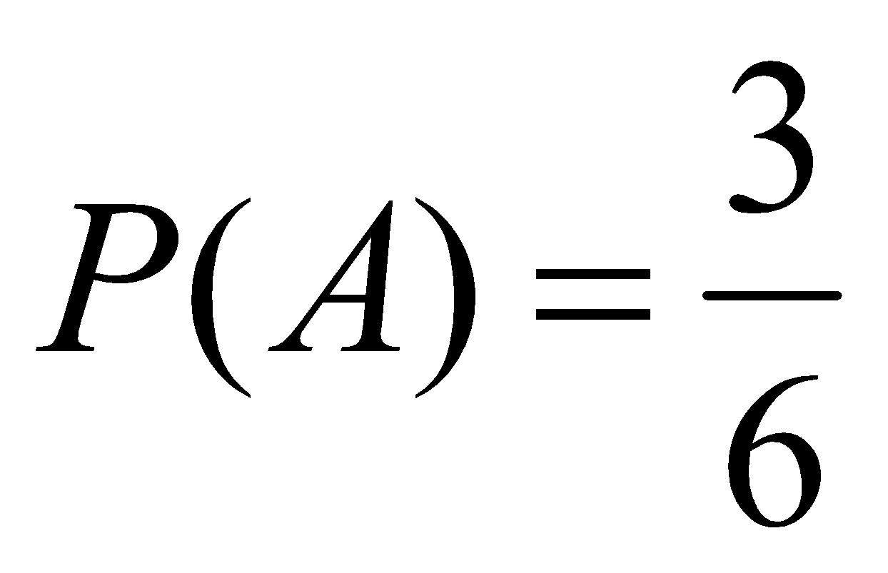

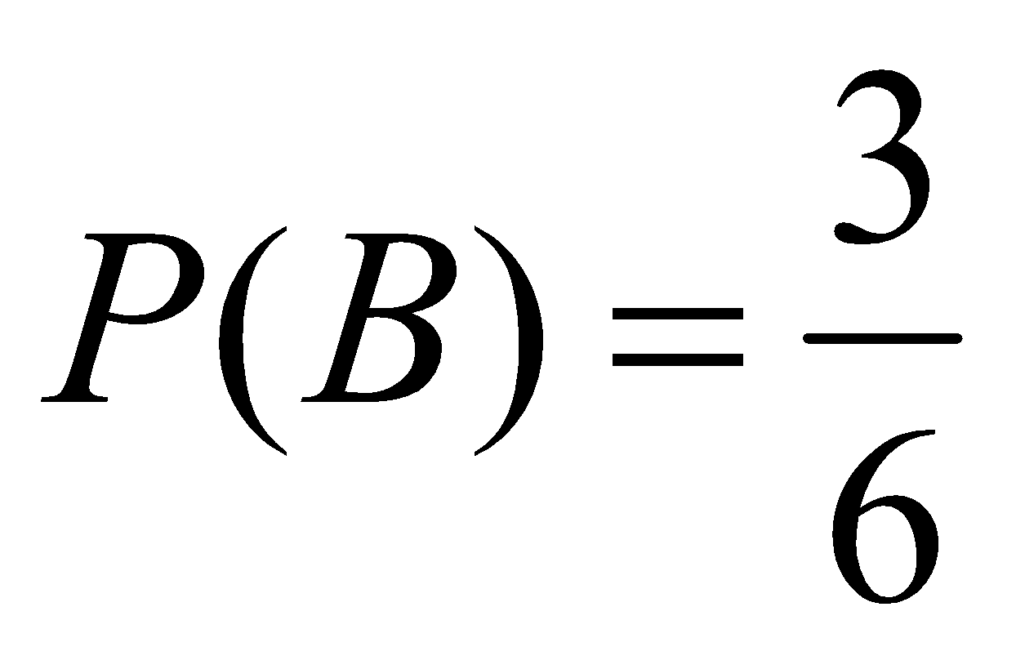

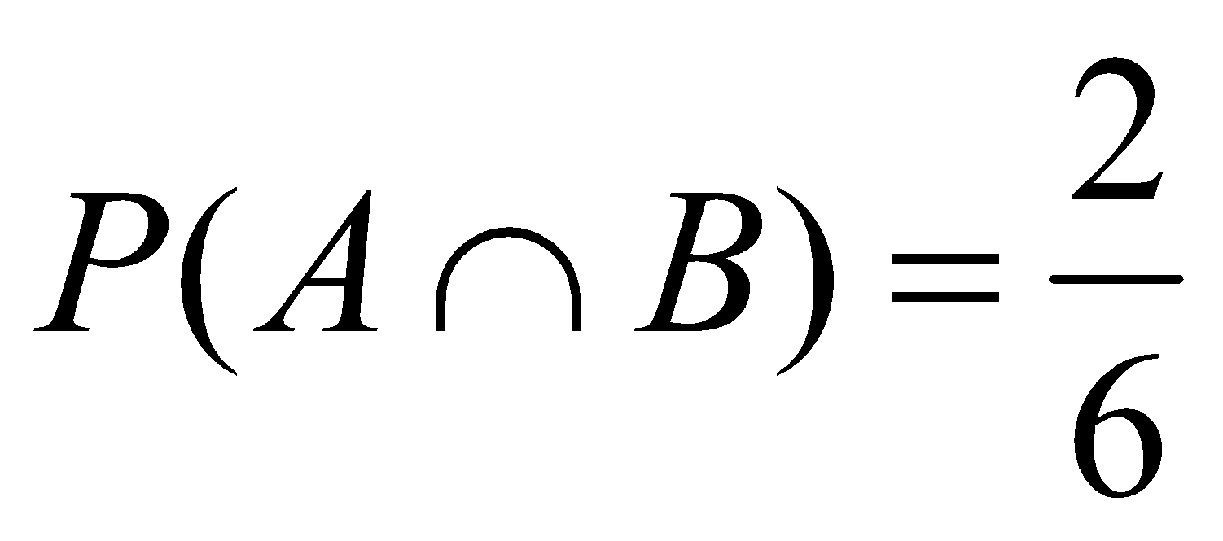

Therefore, 

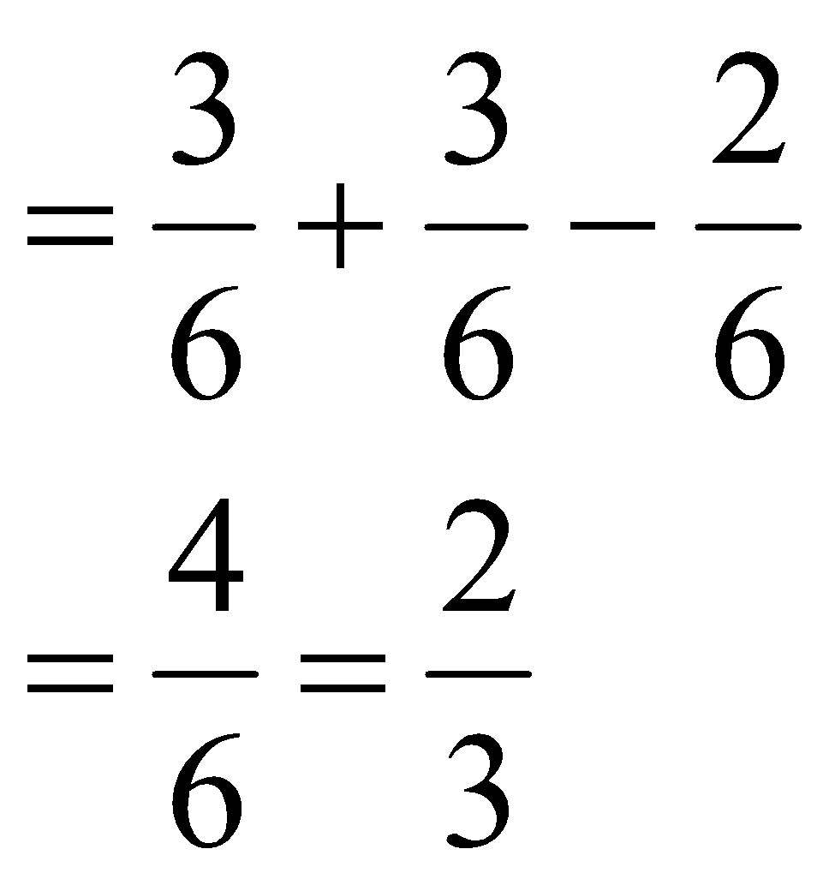

**3.** An investment analyst collects data on stocks and notes whether or not dividends were paid and whether or not the stocks increased in price over a given period. Data are represented in the following table :

Price increase No price increase Total

Dividends paid 34 78 112

No Dividends paid 85 49 134

Total 119 127 246

1. If a stock is selected at random out of the analyst’s list of 246 stocks, what is the probability that it increased in price?
2. If a stock is selected at random, what is the probability that it paid dividends?
3. If a stock is randomly selected, what is the probability that it both increased in price and paid dividends?
4. What is the probability that a randomly selected stock neither paid dividends nor increased in price?

**Solution:**

1. Probability that a stock has witnessed an increase in price = 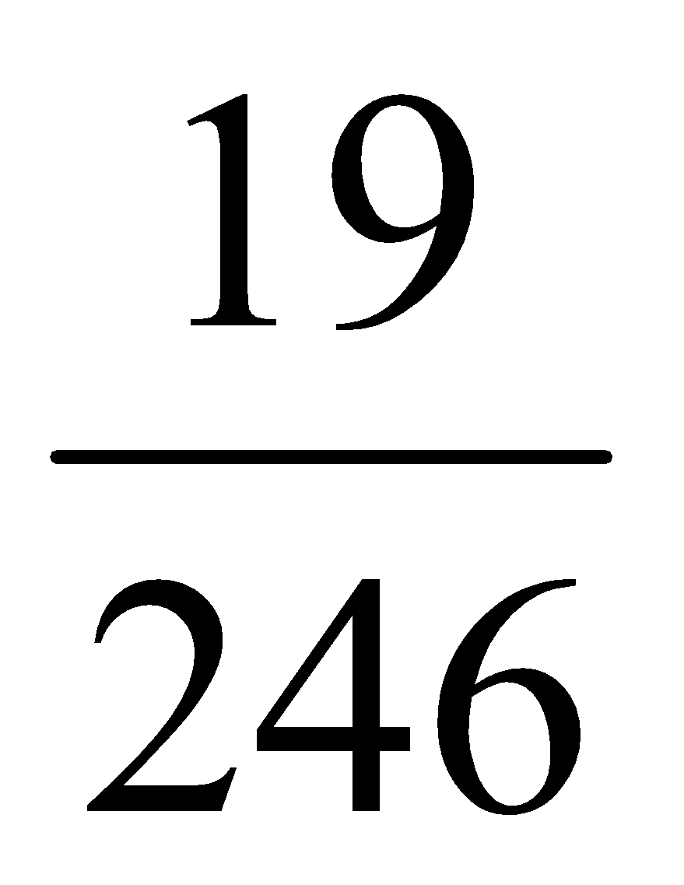
2. Probability that a stock of a company paid dividends = 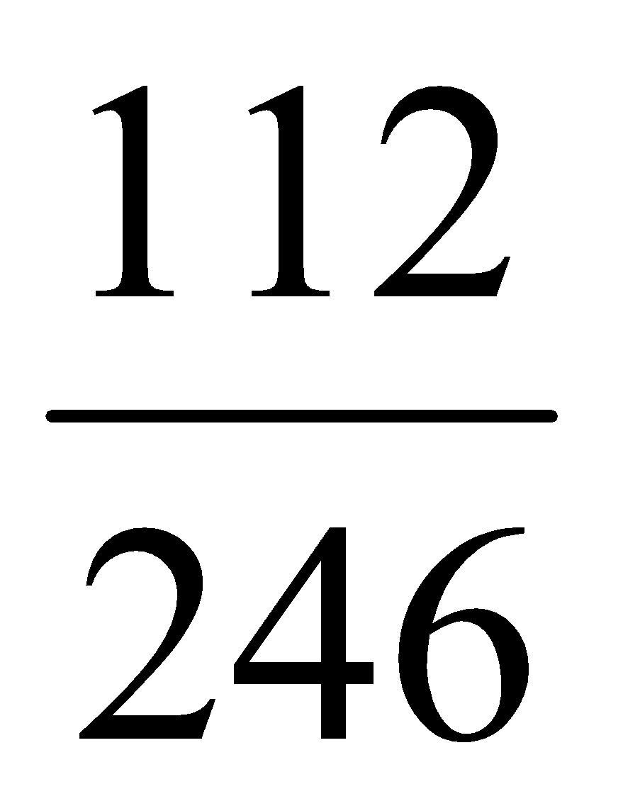
3. Probability that both occurred i.e., increase in price and paid dividends = 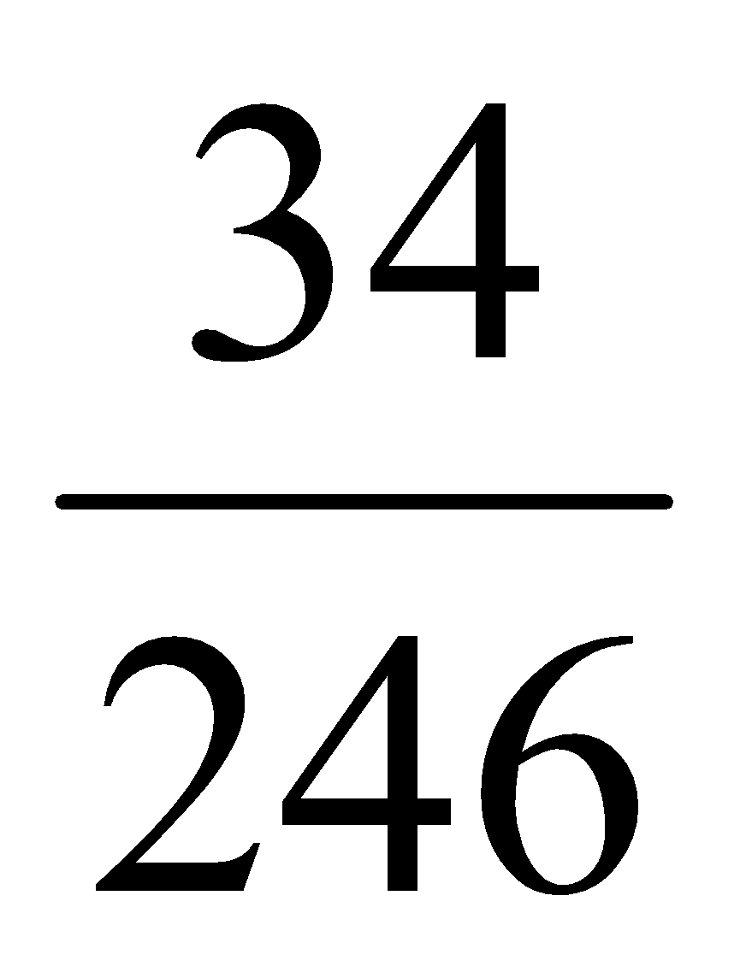
4. Probability that a randomly selected stock neither paid dividends nor increased in price= 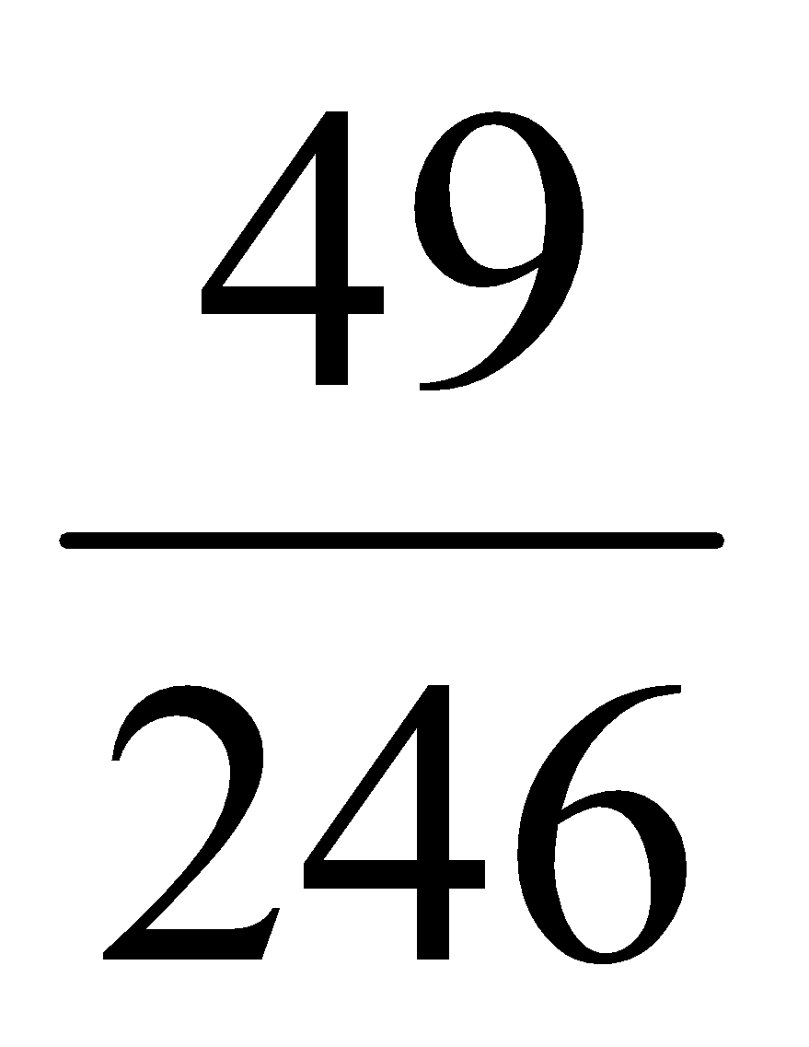

4. What is the probability of getting a sum “Nine” when two dice are thrown?

**Solution:**

Let “A” be the probability of getting a sum “Nine”

n(S) = 62 = 36

A = {(6,3), (3,6), (4,5), 5,4)}

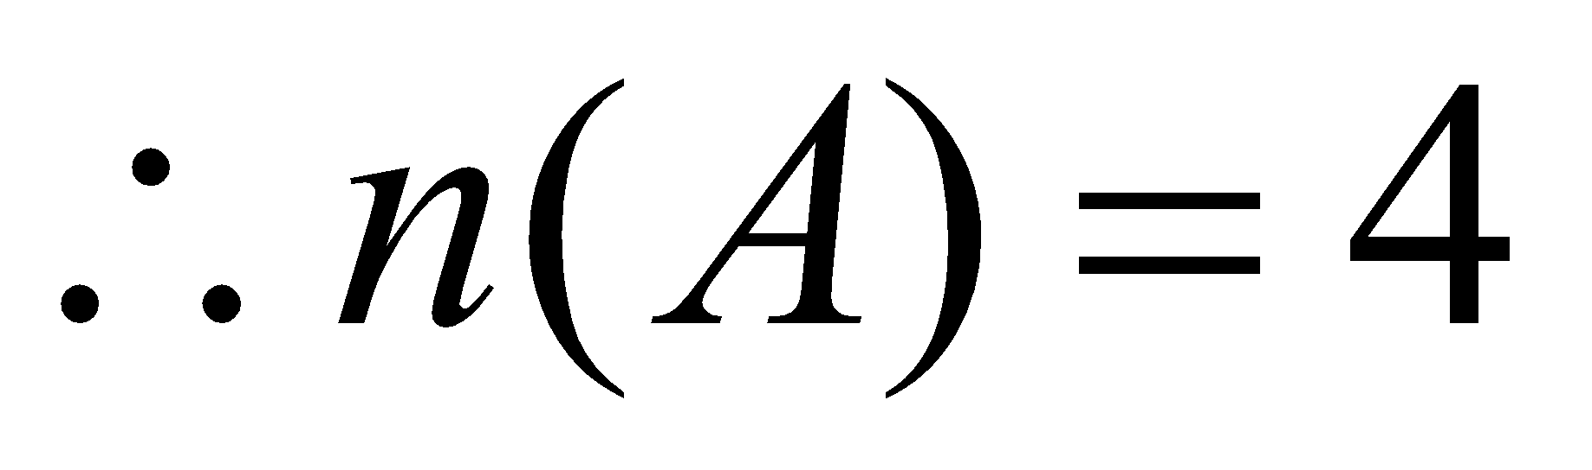

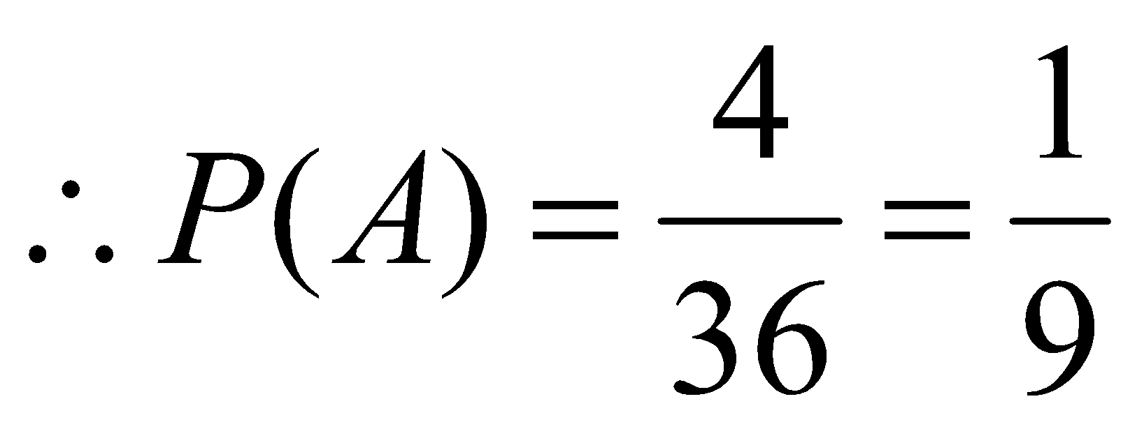

5. Following data gives the information of the defaulters in XYZ bank.

|  |  |  |
| --- | --- | --- |
| Sex | First-time defaulter | Repeat defaulter |
| Male | 60 | 70 |
| Female | 44 | 76 |

Assuming that a defaulter is chosen at random, find:

* 1. the probability that the defaulter is male
  2. The probability that the defaulter is a first-time defaulter, given that the defaulter is male
  3. The probability that the defaulter is female, given that the defaulter is a repeat defaulter.
  4. The probability that the defaulter is female, given that the defaulter is a first time defaulter.

**Solution:**

|  |  |  |  |
| --- | --- | --- | --- |
| Sex | First-time defaulter | Repeat defaulter | Total |
| Male | 60 | 70 | 130 |
| Female | 44 | 76 | 120 |
| Total | 104 | 146 | 250 |

1. P(the defaulter is male) = 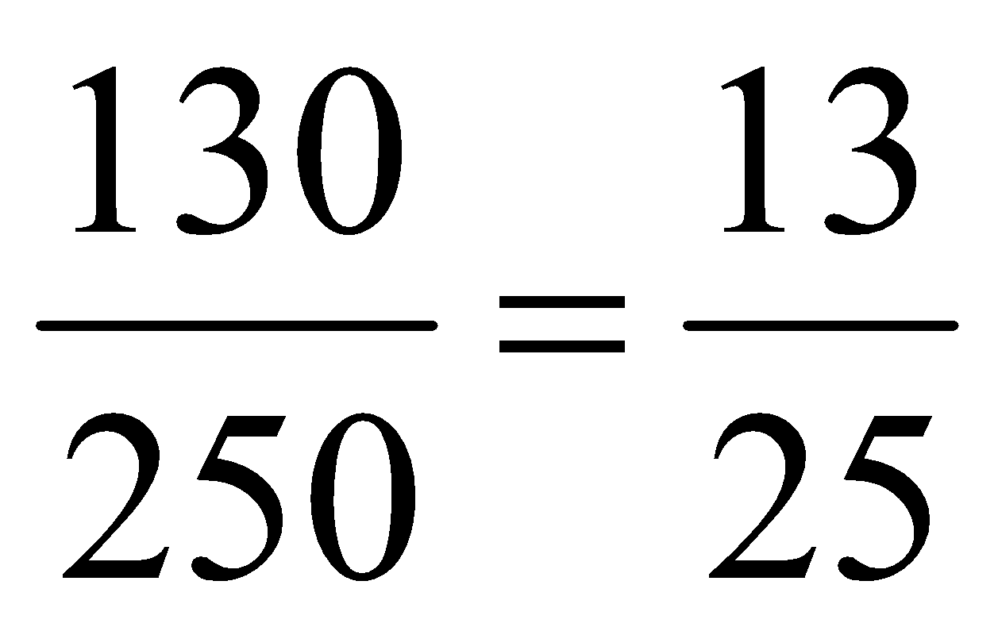
2. Probability that the defaulter is a first-time defaulter, given that the defaulter is male = P(First time/ male) = P(first time and Male)/ P(Male)

= 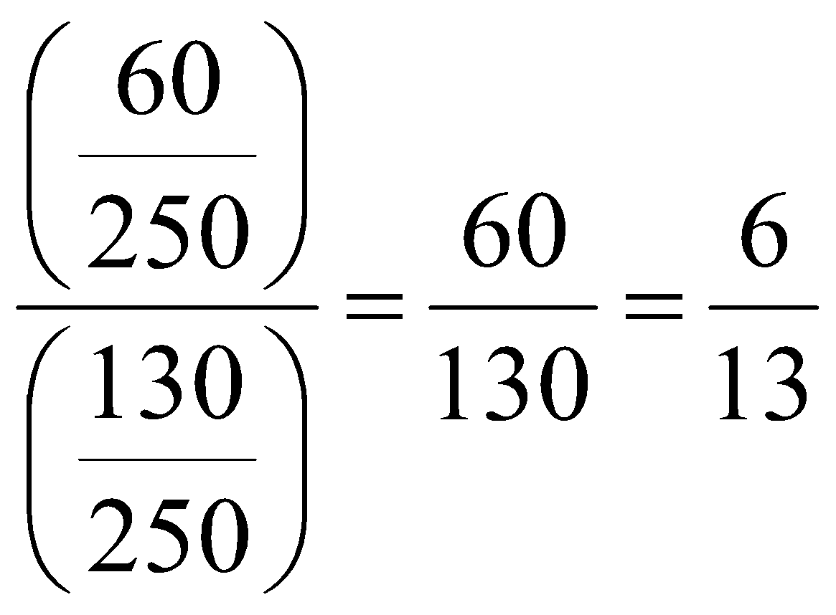

1. Probability that the defaulter is female, given that the defaulter is a repeat defaulter

P(female/ repeat defaulter) = P(Female and repeat defaulter)/P( repeat defaulter)

= 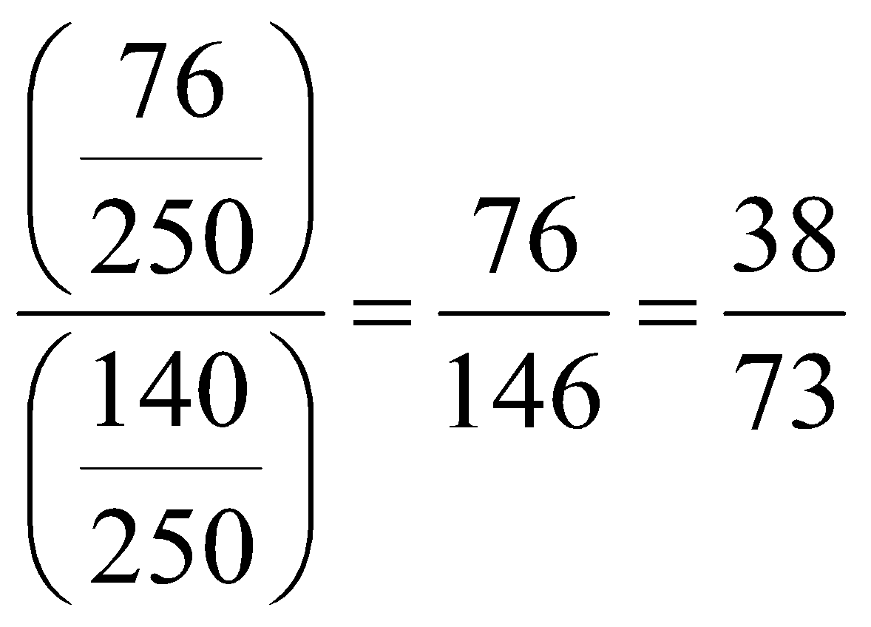

1. Probability that the defaulter is female, given that the defaulter is a first time defaulter.

P(female / first time defaulter) = P (Female and first time defaulter)/ P(first time)

= 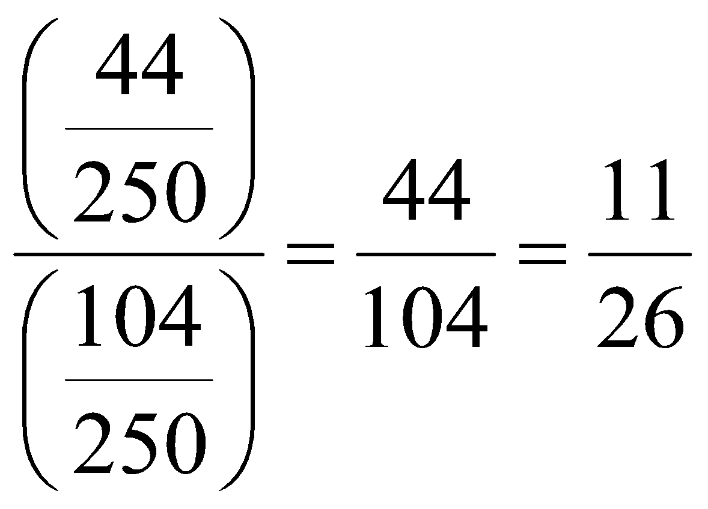

6. The marketing manager of a suitcase manufacturing company is considering the marketing of a new suitcase. In the past, 40% of the suitcases introduced by the company have been successful, and 60% have been unsuccessful. Therefore the suitcase is marketed, market research is conducted and a report, either favorable or unfavorable is compiled. In the past, 80% of the successful suitcases received a favorable market research report. The marketing manager wants to know the probability that the suitcase will be successful if it receives a favorable report.

**Solution:**

The probability that the suitcase will be successful if it receives a favorable report =

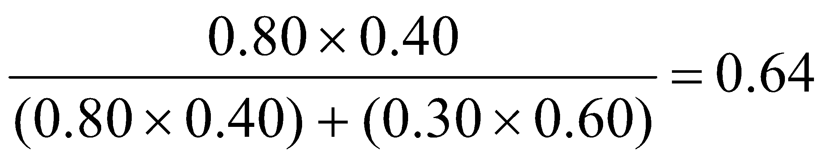

7. A bag contains 5 red and 4 blue similar balls. Two balls are drawn at random from the bag. Find the probability that both of them are red if:

1. the balls are drawn together
2. the balls are drawn one after the other, with replacement
3. the balls are drawn one after the other, without replacement.

**Solution**:

1. Let “A” be the event of drawing two balls together.

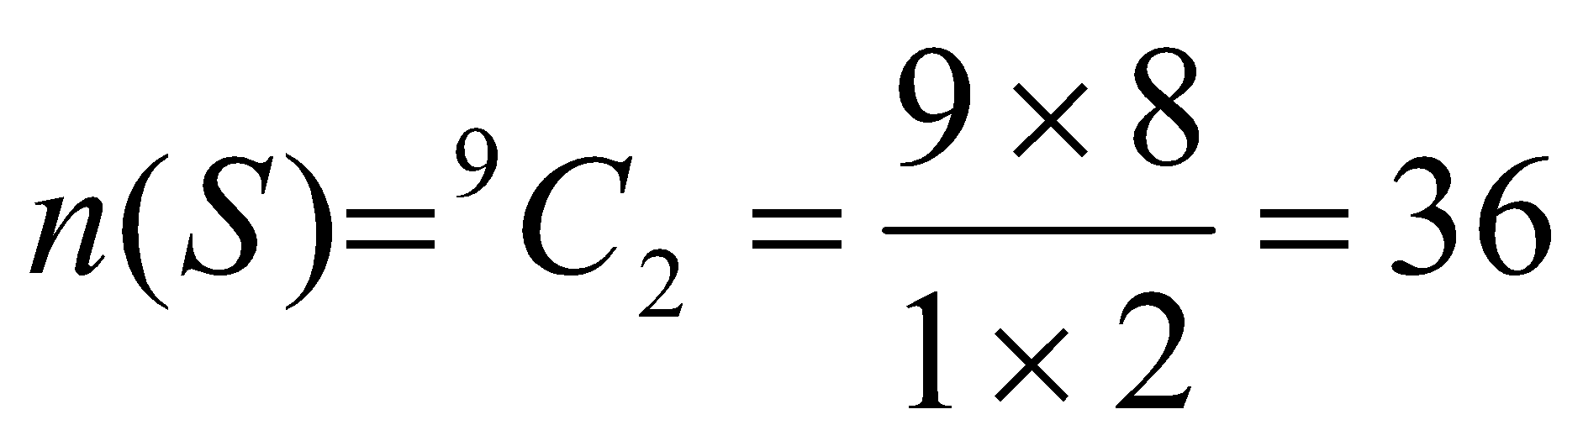 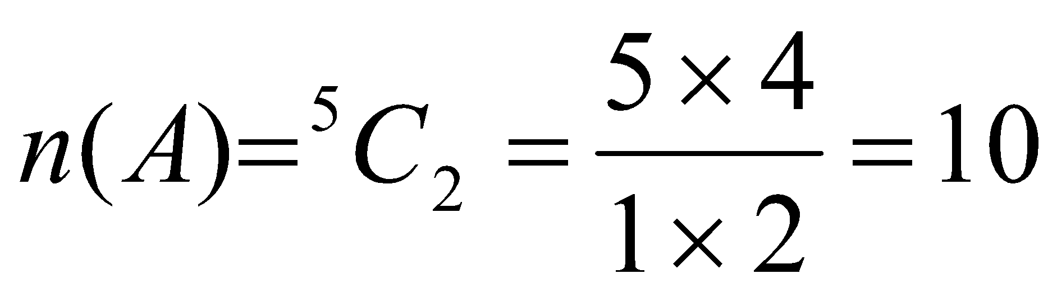

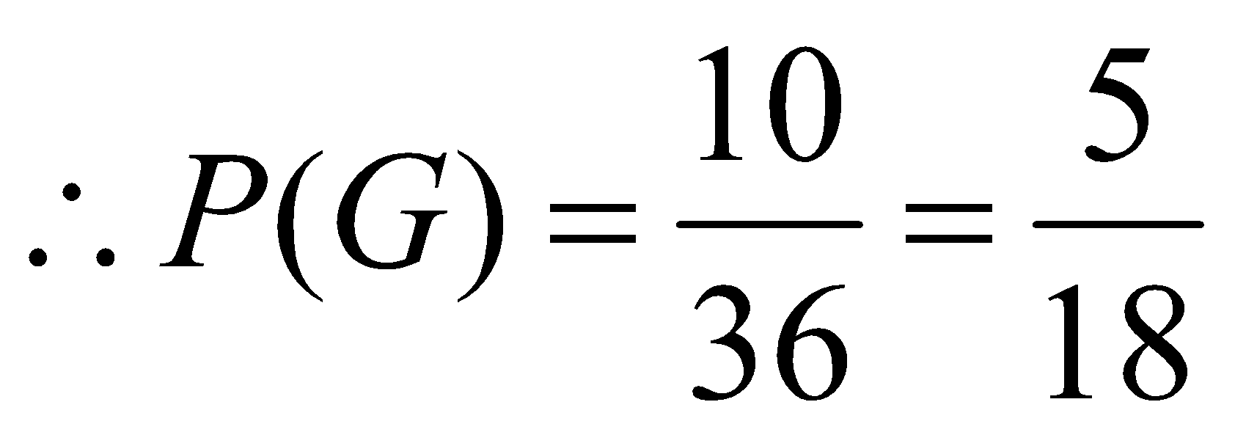

1. Let “A” be the event of drawing a red ball in the first draw

Let “B” be the event of drawing a red ball in the second draw

The required probability is

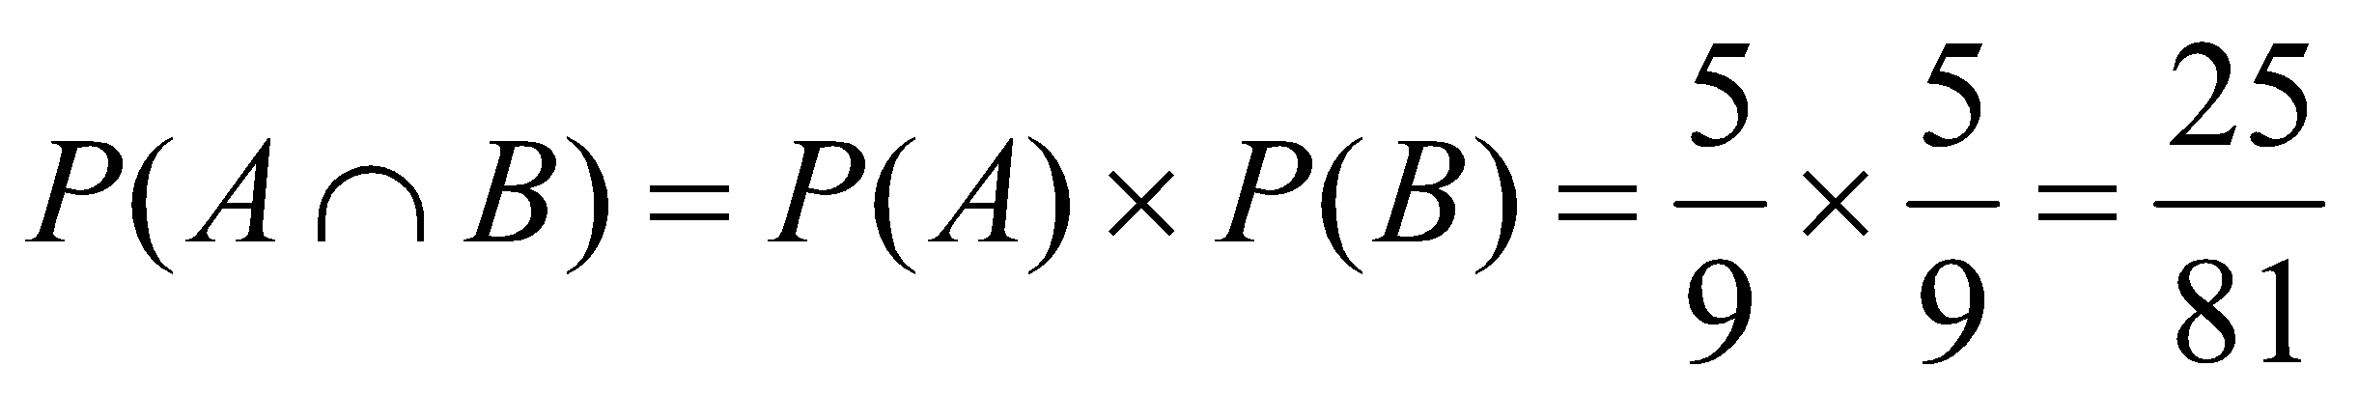 [Since the sample space does not change]

1. Let “A” be the event of drawing red ball in the first draw

Let “B” be the event of drawing red ball in the second draw

Since the first ball is not replaced the sample space changes for second draw

∴ The required probability

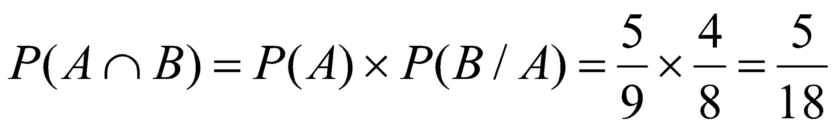

8. A market survey was conducted in four cities to find out the preference for XYZ bank. The responses are shown below:

|  |  |  |  |  |
| --- | --- | --- | --- | --- |
|  | Delhi | Kolkota | Hyderabad | Mumbai |
| Yes | 45 | 55 | 60 | 50 |
| No | 35 | 45 | 35 | 45 |
| No opinion | 5 | 5 | 5 | 5 |

1. What is the probability that a consumer selected at random, preferred XYZ bank?
2. What is the probability that a customer preferred XYZ bank and was from Hyderabad?
3. What is the probability that a consumer preferred XYZ bank given that he was from Hyderabad?
4. Given that a consumer preferred XYZ bank, what is the probability that he was from Mumbai.

**Solution:**

|  |  |  |  |  |  |
| --- | --- | --- | --- | --- | --- |
|  | Delhi | Kolkota | Hyderabad | Mumbai | Total |
| Yes | 45 | 55 | 60 | 50 | 210 |
| No | 35 | 45 | 35 | 45 | 160 |
| No opinion | 5 | 5 | 5 | 5 | 20 |
| Total | 85 | 105 | 100 | 100 | 390 |

Let A denote the event that a customer selected at random preferred XYZ bank, then

1. Probability that a consumer selected at random, preferred XYZ bank is

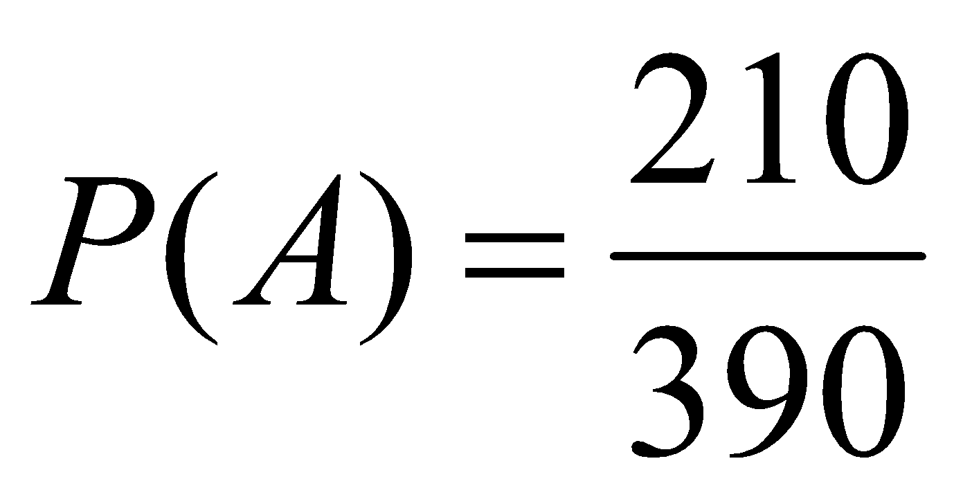

1. Probability that a customer preferred XYZ bank and was from Hyderabad is

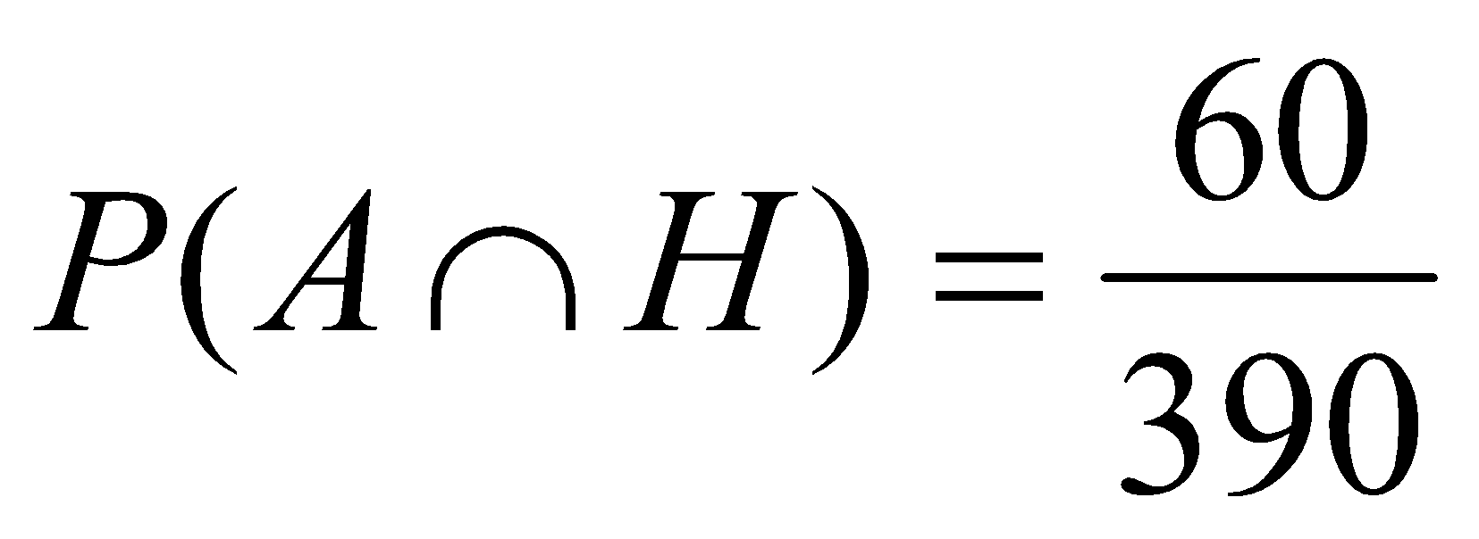

1. Probability that a consumer preferred XYZ bank given that he was from Hyderabad is

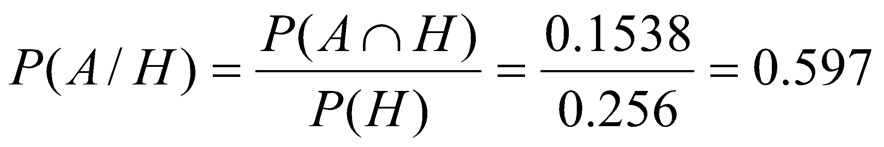

1. The probability that the consumer belongs to Mumbai (M) given that he preferred XYZ bank

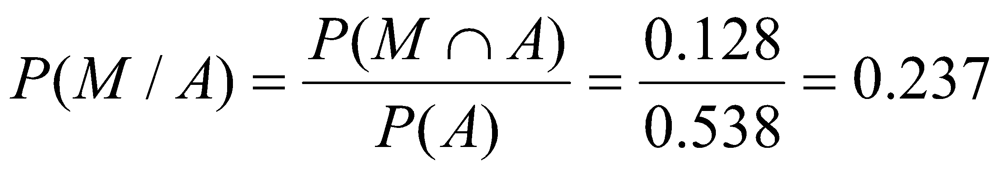

9. Krishna’s travel club has 1000 members, 60% of these members are males. 45% of these members pay by credit card when they travel including 175 females. If a member enters the travel club, including 175 females and if a member enters the travel club at random, what is the probability that:

* 1. The member is a female.
  2. The member is a female and pays by cash.
  3. The member is a male or a credit card user
  4. The member pays cash if we know that the member is a female
  5. Are the sex of the member and the mode of payment statistically independent events?

**Solution:**

|  |  |  |  |
| --- | --- | --- | --- |
|  | Male | Female | Total |
| Credit card | 275 | 175 | 450 |
| Cash | 325 | 225 | 550 |
| Total | 600 | 400 | **1000** |

1. The probability that the member is a female = 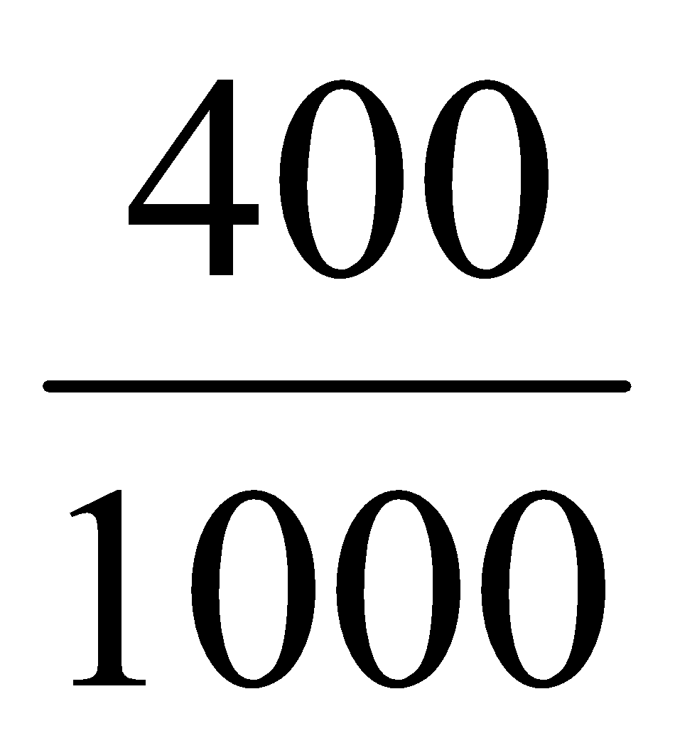
2. The probability that the member is a female and pays by cash = 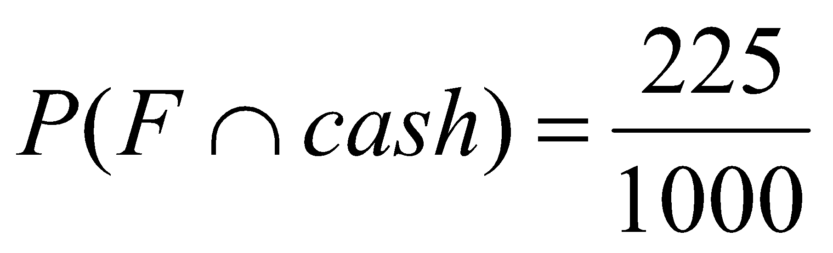
3. The probability that the member is a male or a credit card user

= P(male) + P(credit card user) – P(male and credit card user)

= 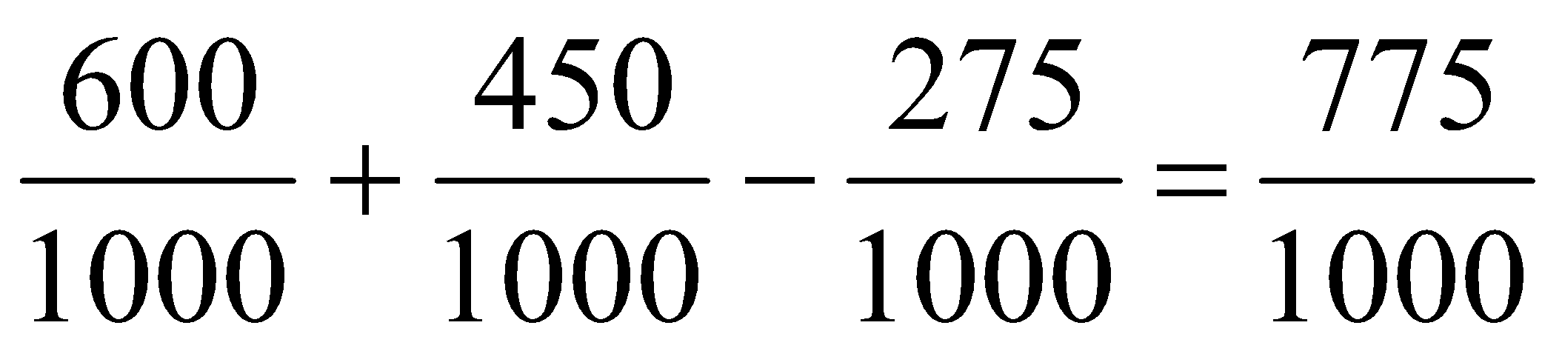

1. The probability that the member pays cash if we know that the member is a female

= P(Cash/ female) = P(Cash∩ female)/ P(Female) = 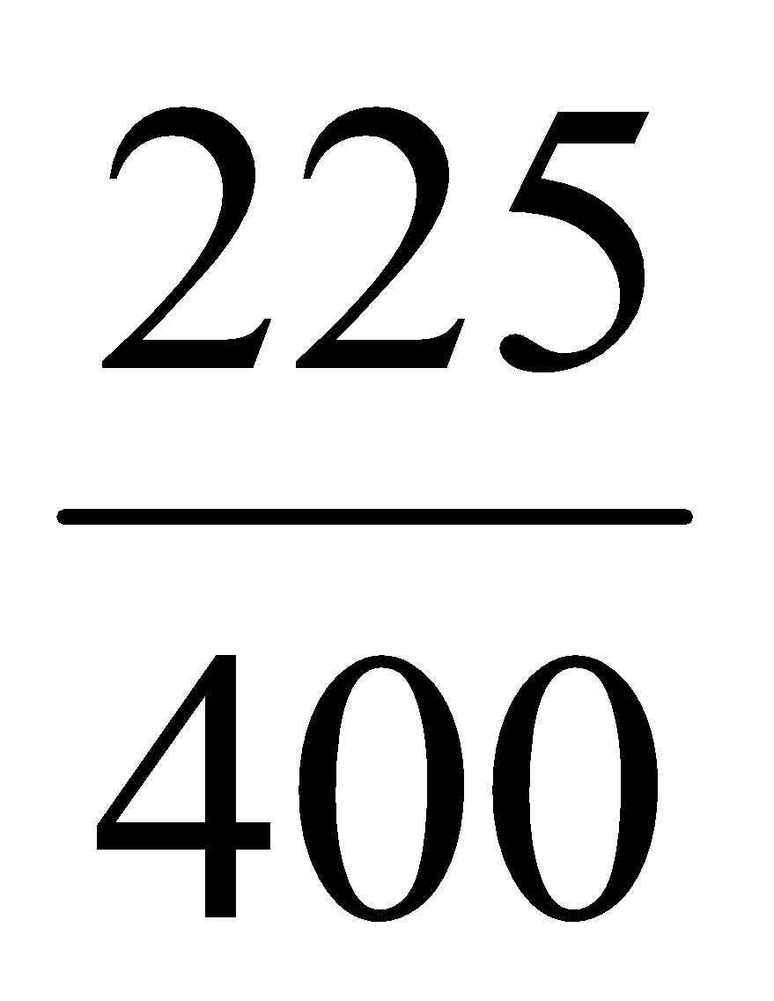

1. Are the sex of the member and the mode of payment are statistically independent events.

Not independent.

10. The probability of X, Y, Z becoming managers are 4/9, 2/9 and 1/3 respectively. The probability that Bonus scheme will be introduced if X, Y and Z becomes Managers are 3/10, ½ and 4/5 respectively.

1. What is the probability that Bonus scheme will be introduced?
2. If the bonus scheme has been introduced what is the probability that manager appointed for x.

**Solution:**

Let the probability of X, Y and Z becoming managers are 4/9, 2/9 and 1/3

Let B denotes the bonus scheme.

Given,

P(X becomes manager) =  P(B/X) = 

P(Y becomes manager) =  P(B/Y) = 

P(Z becomes manager) =  P(B/Z) = 

1. Probability that Bonus scheme will be introduced = 

= 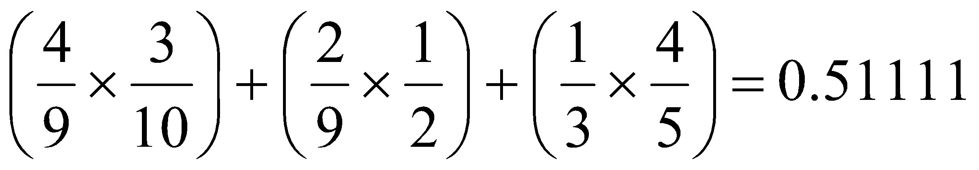

1. 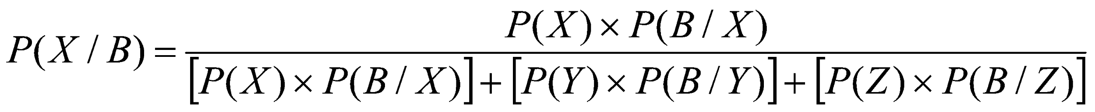

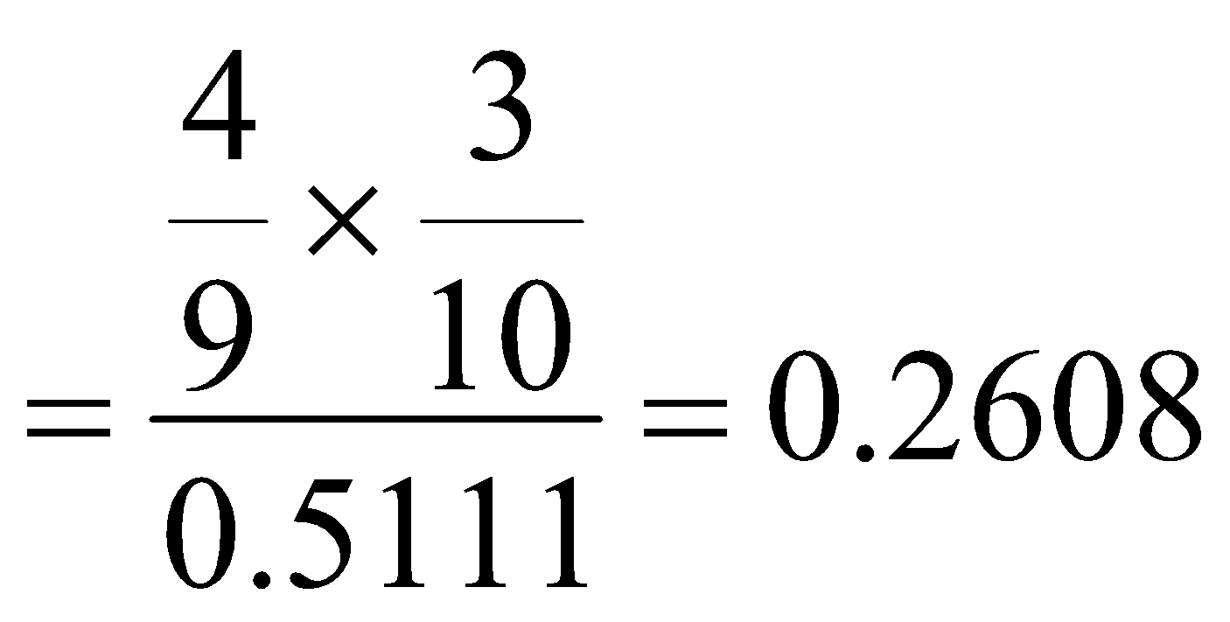

11.A box contains 4 red and 5 blue similar rings. What is the probability of selecting at random:

1. two rings having same colour
2. having different colour

**Solution:**

Given total rings = 4 + 5 = 9

Two rings of the same colour can be selected in 9C2 ways = 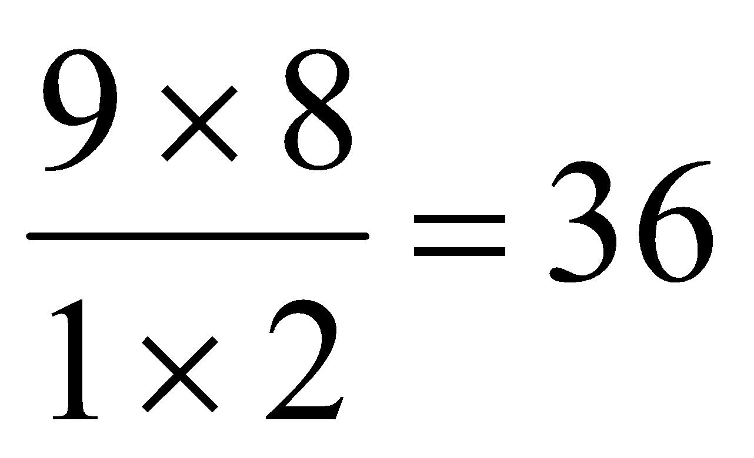

1. Two rings same colour = may be either red **or** blue

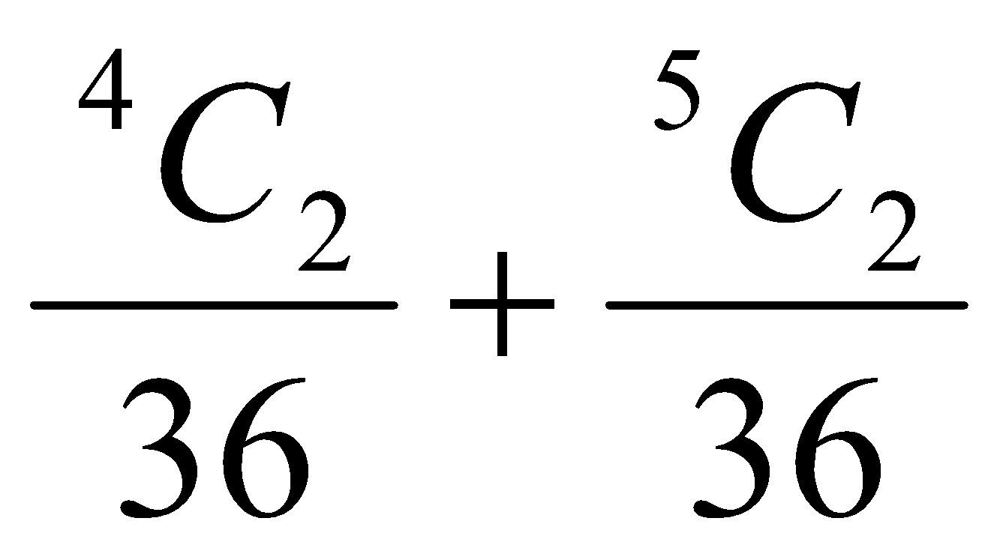

= 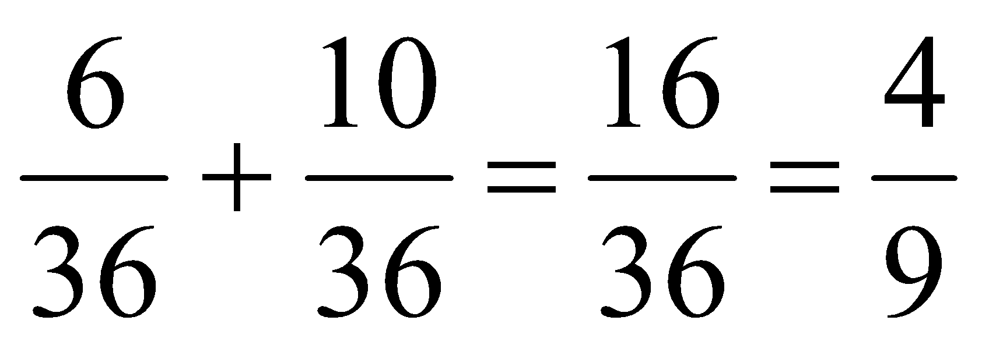

1. Having different colors
   * + 1. P(having same color) = 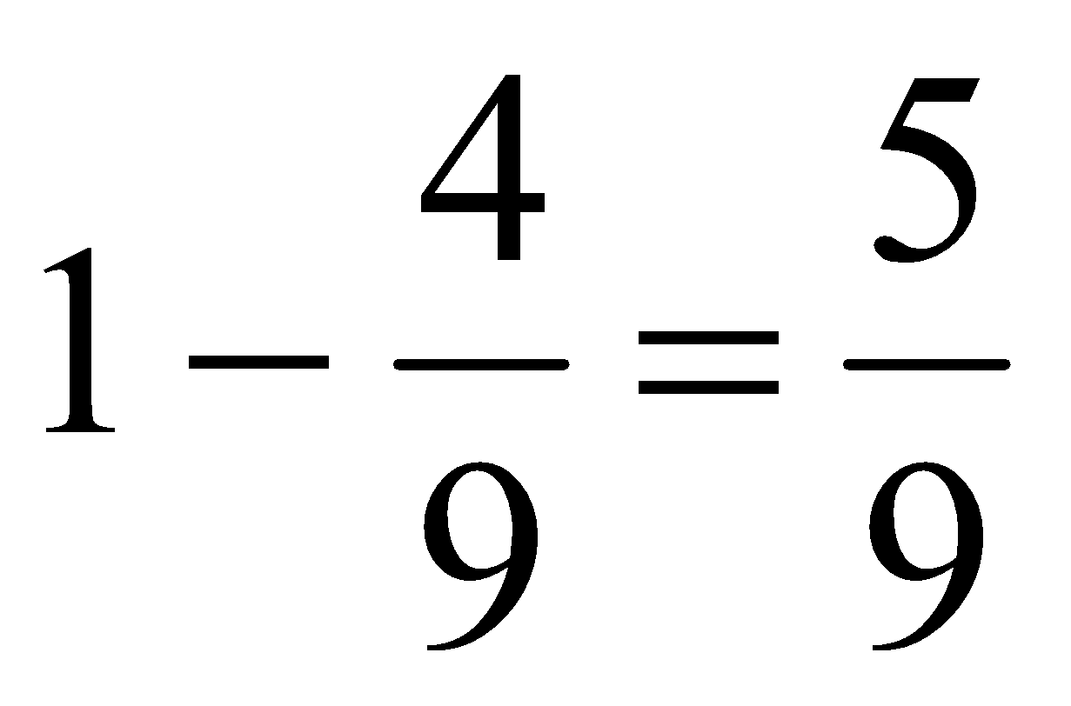

12. The probability that a company A will survive for 20 years is 0.6. The probability that its sister concern will survive for 20 years is 0.8. What is the probability that at least one of them will survive for 20 years?

**Solution:**

P(Company A will survive for 20 years) P(A) = 0.6

P(its sister concern will survive for 20 years) P(B) = 0.8

P(at least one of them will survive ) = P(A∪B) = P(A) + P(B) – P(A∩B)

= 0.6 + 0.8 – 0.48 = 0.92

13. In a survey, the probability that a family makes equity investments if its annual income exceeds Rs. 3,50,000 is 0.75. Of the surveyed families, 60% have income exceeding Rs. 3,50,000 and 52% have equity investments. What is the probability that a family has equity investments and income over Rs. 3,50,000?

**Solution:**

Let A denote equity investments

Let B denote income exceeding Rs. 3,50,000

Given P(A)= 0.52 ; P(B) = 0.6 and P(B/A) = 0.75, we are suppose to find P(AB)

We know that,

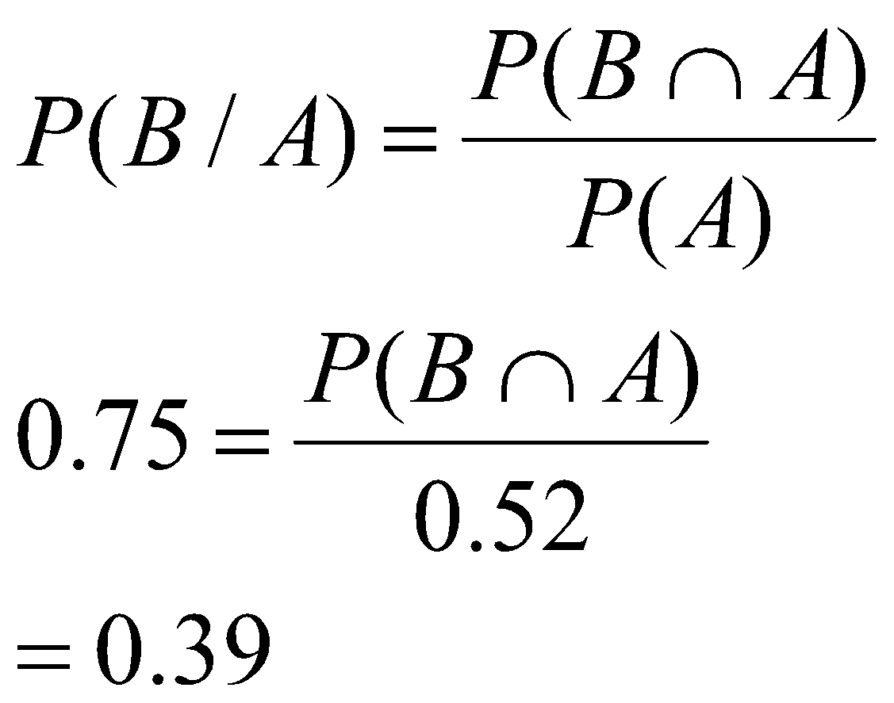

14. A certain item is manufactured by three factories F1, F2 and F3. It is known that factory F1 turns out twice as many items as F2 and that F2 and F3 turn out the same number of items in one day. It is also known that defective percent of items from these factories is 2%, 2% and 4% respectively. One item is chosen at random from the mixed lot of items from these factories. The chosen item is found to be defective. Find the probability that this item is produced at the factory F1.

**Solution:**

Probability of manufacturing in F1 = 0.5 Probability of defective % (D) = 0.02

Probability of manufacturing in F2 = 0.25 Probability of defective % (D) = 0.02

Probability of manufacturing in F3 = 0.25 Probability of defective % (D) = 0.04

Probability (item is produced by factory 1/ defective)

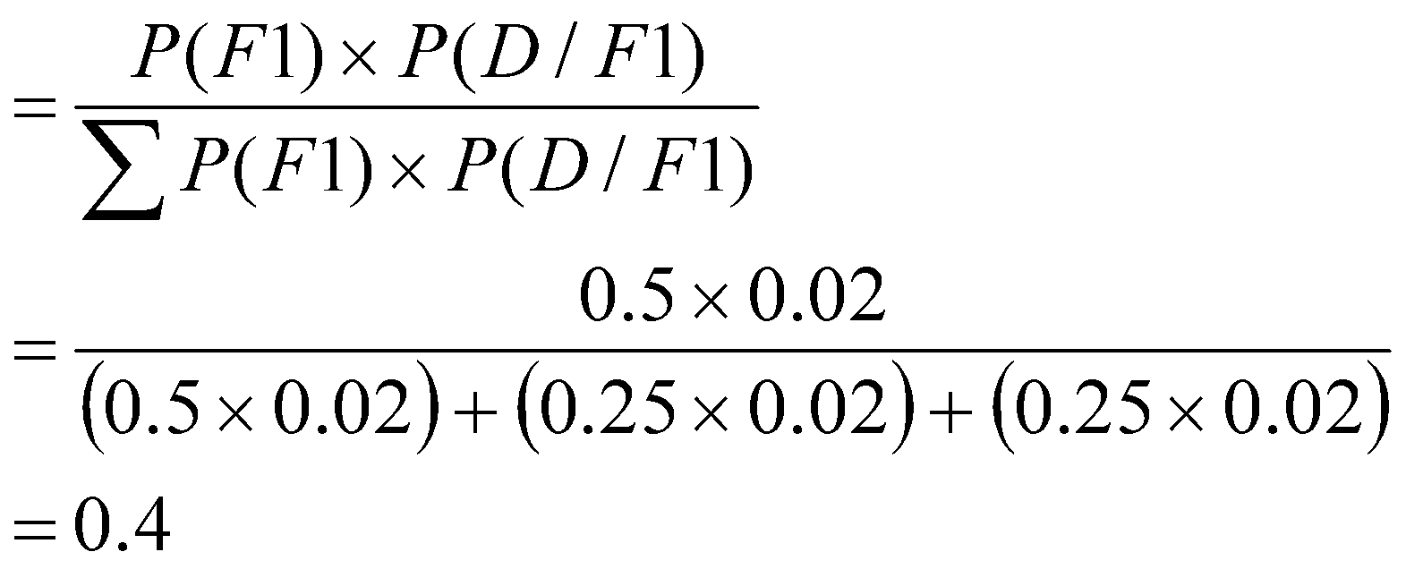

15. Three similar machines A, B and C are used to make a component. Machine A is new and produces 40% of the total output; machines B and C each produce 30% of the output. The percentage of defective component produced by machine A is 1% and the corresponding percentages for machines B and C are 4% and 7% respectively.

* + - 1. If a component is selected at random, find the probability that the component is defective.
      2. If a component is found to be defective, find the probability that the component was made by machine C.

**Solution:**

Given the following

Probability that Machine A contributes = 0.4 P( D/ machine A) = 0.01

Probability that Machine B contributes = 0.3 P( D/ machine B) = 0.04

Probability that Machine C contributes = 0.3 P( D/ machine C) = 0.07

*Where D = Defective component*

* + 1. P(selected component is defective) = 



= 0.037

* + 1. P( Machine C/ defective) = 